Lesson Plan Lesson 1(Unit 9)

Interchange Full Contact 3

Teacher: Prozorovschi Daria

Topic: “At Your Service”
Date: 08.04.15
Nr. | Stages | Procedure | Needed Materials
1. | Evocation | 1. Homework check.  2. Listen to an audio advertisement and write down the services this company provides? | Track 16  CD 2
2. | Realization of meaning | 1. Grammar Focus  a. Look at the pictures and define the problem these people have.  b. What solutions can you advise for these problems?  Use “have/ get” to describe a service performed by someone else.  Active: He can get a repair shop to repair his bike.  Active: She can have the Sewing Workshop to shorten her skirt.  2. Each of you will get a set of pictures describing situations where you need someone to perform for you these types of services.  On the wall you have some advertisement for different services. Go around and complete the chart with the places you can get these services performed. | Power Point “What is the problem?”  Advertisement  Chart “At Your Service”
3. | Reflection | 1. Group Work.  Select a strip of paper with a situation described on it. Read the statement and ask your colleagues where you can have these services done for you. When you give the advice, mention the organization that provides these services. (use the advertisements from the walls)  Model:  - Do you know where I can get someone to shorten my skirt?  - You can have your skirt shortened at “Star Tailoring”.  shorten my skirt  cut my hair for a reasonable  fix my scooter  clean my leather jacket  upgrade my computer  see the tourist attractions  improving your math grades  remove a chocolate stain from my dress | Ex. 3 B p. 59  S/B  strips of paper describing a situation
4. | Extension | 1. Homework: Work out a list of places you may have these services  performed.  Do Ex. 5p. 60 | Do Ex. 5p. 60  S/B


- - - - - - - - - - - - - - - - - - - - - - - - - - - - - - - - - - - - - - - - - - - - - - - - - - - - - - - - - - - - - - - - -





- - - - - - - - - - - - - - - - - - - - - - - - - - - - - - - - - - - - - - - - - - - - - - - - - - - - - - - - - - - - - - - - -





- - - - - - - - - - - - - - - - - - - - - - - - - - - - - - - - - - - - - - - - - - - - - - - - - - - - - - - - - - - - - - - - -





the situation | the problem | the place you can have the service performed.


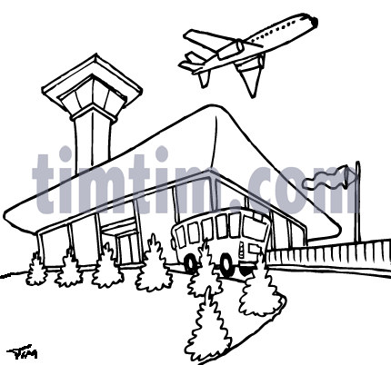
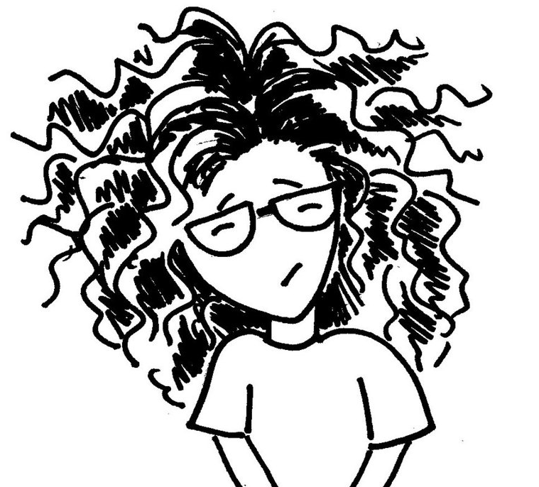

- - - - - - - - - - - - - - - - - - - - - - - - - - - - - - - - - - - - - - - - - - - - - - - - - - - - - - - - - - - - - - - - -

the situation | the problem | the place you can have the service performed.
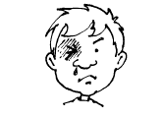
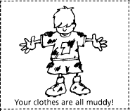

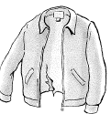

the situation | the problem | the place you can have the service performed.


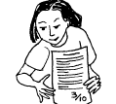


- - - - - - - - - - - - - - - - - - - - - - - - - - - - - - - - - - - - - - - - - - - - - - - - - - - - - - - - - - - - - - - - -

the situation | the problem | the place you can have the service performed.
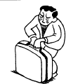
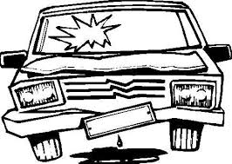
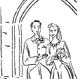
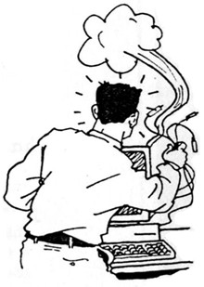

shorten my skirt
cut my hair for a reasonable
fix my scooter
clean my leather jacket
upgrade my computer
see the tourist attractions
improving your math grades
remove a chocolate stain from my dress

shorten my skirt
cut my hair for a reasonable
fix my scooter
clean my leather jacket
upgrade my computer
see the tourist attractions
improving your math grades
remove a chocolate stain from my dress

